4 Test Plot
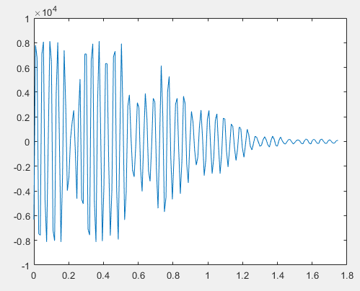
I could not get the plot to show a range of about 2 meters. The closest I could get is the 1.8 meters shown above using a stop time of 24500 ps.

8 Time Values
All values are given in microseconds (μs)
PII = 6 | 7 | 8 | 9 | 10 | 11 | 12 | 13 | 14 | 15
101 | 203 | 406 | 811 | 1622 | 3244 | 6489 | 12977 | 25955 | 51910

9b Difference Scans
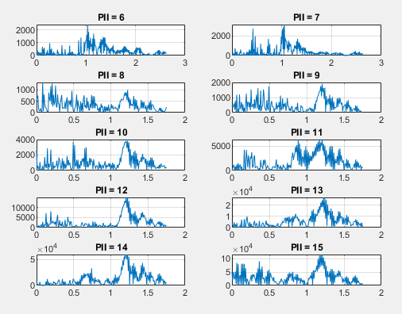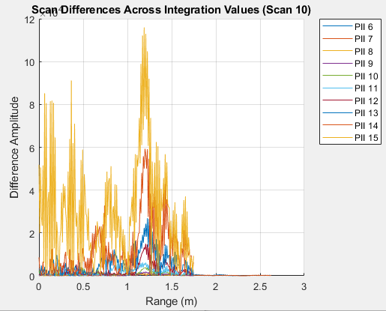
9h SNR Plot
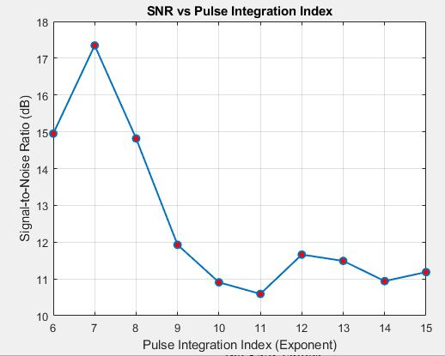
There is no visible relationship. The values generally decreased as PII increased, though this is not the case for every PII value (ex. PII = 12-15).

9 MATLAB Commands
Below are the commands used for part 9. The same commands were repeated for every PII, though PII = 6 is the only one that appears below for simplicity.
% Load background and target scan data
[cfgb,reqb,scnb6,detb] = readMrmRetLog('background6new.csv');
[cfgt,reqt,scnt6,dett] = readMrmRetLog('target6new.csv');

% Extract the raw background scan
rawscansIb6 = find([scnb6.Nfilt] == 1);
rawscansV_background6 = reshape([scnb6(rawscansIb6).scn],[],length(rawscansIb6))';

% Extract the raw target scan
rawscansIt6 = find([scnt6.Nfilt] == 1);
rawscansV_target6 = reshape([scnt6(rawscansIt6).scn],[],length(rawscansIt6))';

% Calculate the difference scan
scan_difference6 = abs(rawscansV_background6 - rawscansV_target6);

% Plot the difference scan
Tbin = 32/(512*1.024);
T0 = 0;
c = 0.29979;
Rbin = c*(Tbin*(0:size(scan_difference6,2)-1) - T0)/2;

plot(Rbin, scan_difference6(10,:));
xlabel('Range (m)');
ylabel('Difference Amplitude');
title('Difference Scan, PII = 6');
grid on;

% Calculate signal and noise power
[a6, i] = max(scan_difference6(10,:));
noise_var6 = var(scan_difference6(10,125:175));

% Calculate SNR in dB
SNR6 = 10*log10(a6^2/noise_var6);

Questions
- The measured SNR did not follow the expected pattern of getting steadily stronger with every step up in the PII setting. While increasing the setting from 6 to 7 gave a brief boost, setting it any higher caused the signal quality to drop drastically and stay low. Since the radar was pointing at a stationary target, this happened because the radar's internal timing lost precision over longer recording periods, causing the combined signals to scramble and cancel each other out, and the system's computer likely got overwhelmed by trying to stack too much data at once. This can be fixed by lowering the recording power to prevent the system from getting overloaded, keeping the settings within the limits of the internal clock's accuracy, or turning off the timing sensitivity so the signals don't clash when added together.
- As the PII increases, the time required to complete a scan increases exponentially. Each increase of one in PII doubles the minimum scan time for the same number of quanta. This means higher PII values require longer scan times but allow for greater signal integration, while lower PII values provide faster scan updates.

